**CAPSTONE PROJECT 1**

**PROJECT NAME: DAILY EXPENSE TRACKER**

**EXPENSE DATABASE SCHEMA DIAGRAM:**

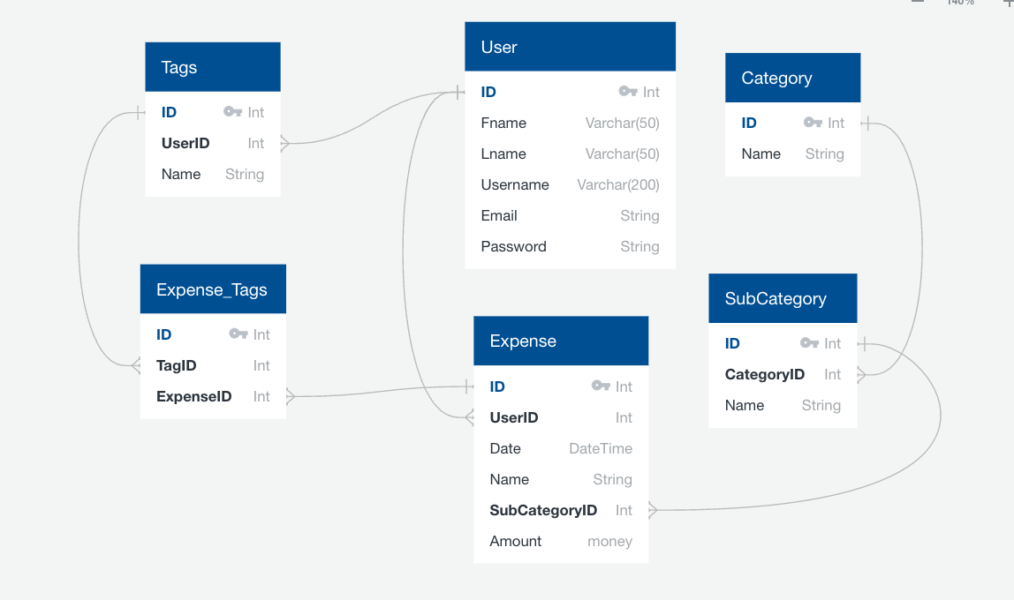

**USERS API:**

**GET /**

Shows start page with signup and login option

**GET /register**

Show a form to register a user. This form should accept a First Name, Last Name, username, email, password.

**POST /register**

Process the registration form by adding a new user. Then redirect to **/home.**

**GET /login**

Show a form to enter the username and password and submitted will login a user.

**POST /login**

Process the login form, ensuring the user is authenticated and redirect to **/home**

**GET /category**

Show a form to list the categories with edit and delete button. And also have an add button to create a new category

**GET /category/add**

Show a form to add a category. This form should accept category name.

**POST category/add**

Process a form to add the name of category and validate category name to avoid duplicates.

**DELETE /category/<category-id>**

Delete the specific category.

**GET / subcategory**

Show a form to list the subcategories with edit and delete button. And also have an add button to create a new subcategory.

**GET /subcategory/add**

Show a form to add a subcategory under the category. This form should accept category name under the list of categories and subcategory name.

**POST /subcategory/add**

Process a form to add the name of subcategory under the category name.

**DELETE /subcategory/<category-id>**

Delete the specific subcategory.

**GET /user/<user-id>/ tags**

Show a form to list tags on current month basis with edit and delete button. And also have an add button to create a new tag.

**GET /user/<user-id>/tags/add**

Show a form to add a tag. This form should accept category name.

**POST /user/<user-id>/tags/add**

Process a form to add tag name.

**DELETE /user/<user-id>/tags/<tag-id>**

Delete the specific tag name.

**GET /user/<user-id>/category/<tag-id>/edit**

Show a form to edit a tag.

**POST /user/<user-id>/category/<tag-id>/edit**

Process edit form, edit tag and redirect to **/user/<user-id>/ tags**

**GET /user/<user-id>/ expense**

Show a form to list the expense with edit and delete button. And also have an add button to create a new expense.

**GET / user/<user-id>/expense/add**

Show a form to add an expense. This form should have Date, Name, subcategory, amount.

**POST / user/<user-id>/expense/add**

Process a form to add an expense to track daily basis.

**DELETE /user/<user-id>/ expense /<expense-id>**

Delete the specific expense detail.

**GET /user/<user-id>/ expense /<expense-id>/edit**

Show a form to edit an expense detail.

**POST /user/<user-id>/ expense /<expense-id>/edit**

Process edit form, edit expense and redirect to **/user/<user-id>/ expense**

**GET /user/<user-id>/reports**

Show the reports based on a Day, Month, category, subcategory, tags.